Nov 17 9709/11
5.

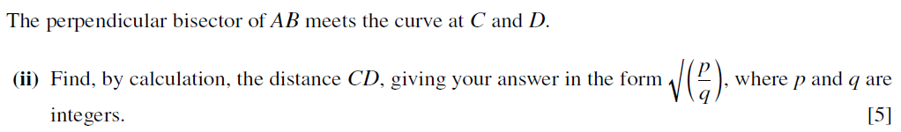
7(a).
10.

